**Sanjivani College of Engineering,**

**Department of Computer Engineering.**

**DATABASE MANAGEMENT SYSTEM LABORATORY.**

* Name: Nikita Rajendra Bhawar
* Class: SY A
* Roll No.:18
* PRN No. : UCS21F1018
* Assignment No.:2
* Problem Statement:-

Design at least 10 SQL queries foe suitable database application using SQL DML Statements : Insert, Select , Update, Delete with operators, function, and set operators , all types of join, sub- query and view.

* Database Name: Alumni Management System.
* DML Commands :-
* ***Create a database:***

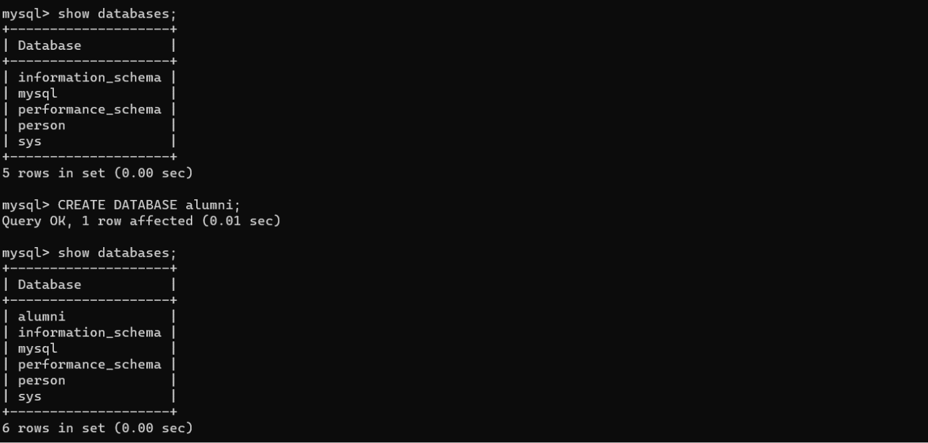 CREATE DATABASE alumni;

* ***Create Command:***

1. CREATE TABLE Student (Name varchar(50) NOT NULL, Sid varchar(50) NOT NULL,Pyear varchar(70) NOT NULL,Cid varchar(40) NOT NULL,Dname varchar(50) NOT NUL);

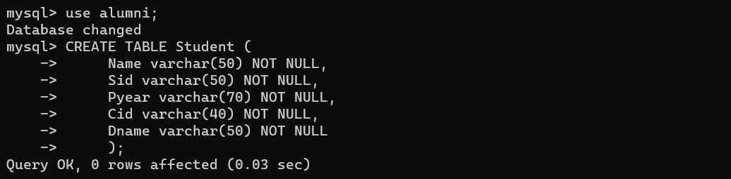

1. CREATE TABLE Company (Cname varchar(40) NOT NULL,Cid varchar(50) NOT NULL,Post varchar(30) NOT NULL,Sid varchar(40) NOT NULL,Domain varchar(40) NOT NULL,Location varchar(70) NOT NULL);

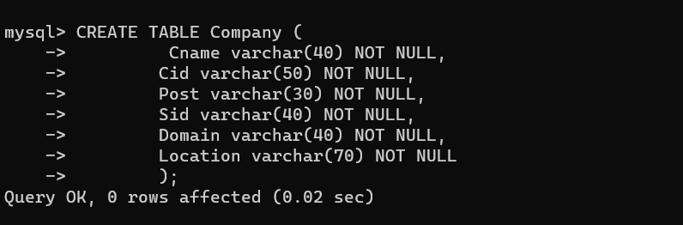

1. 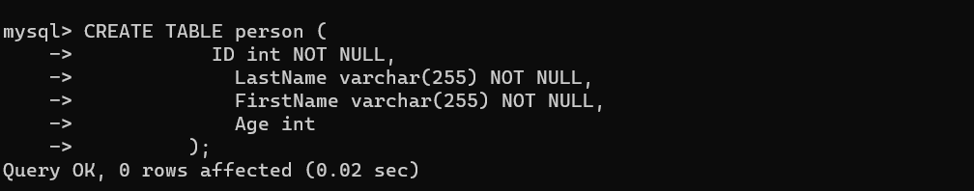CREATE TABLE person (ID int NOT NULL,varchar(255) NOT NULL,FirstName varchar(255) NOT NULL, Age int);

* ***Insert Command:-***

INSERT INTO Student values('Sarika kape',01,2004,01, 'computer');

INSERT INTO Student values('Sagar Ware',02,2004,02,'computer');

INSERT INTO Student values('Rahul Ghume',03,2015,03,'computer');

INSERT INTO Student values('Harsh kalra',04,1998,04,'computer');

INSERT INTO Student values('Yogesh Shrivastava',05,1999,05,'computer');

INSERT INTO Student values('Amit Joshi',06,2003,06,'computer’);

INSERT INTO Student values('Amit kolhe',07,2004,07,'computer');

INSERT INTO Student values( 'Rajeev koul',08,2000,08,'computer');

INSERT INTO Student values('prajkta wandekar',09,2004,09,'computer');

INSERT INTO Student values('prakash Admane',10,2005,10,'computer');

INSERT INTO company values('Fidelity Investment',01,'Lead software Engineer',01,'web developer','Bengaluru');

INSERT INTO company values('EXPO Optical electricals',02,'Technical lead',02, 'Agile', 'pune');

INSERT INTO company values('Jaguar Land Rover',03, 'Senior RPA', 03,'RPA','pune');

INSERT INTO company values('Eggspert Nutri Innovations',04,'Managing Director',04,'xyz','delhi' );

INSERT INTO company values( 'General Electric', 05,'Repair',05,'Repair','ohio');

INSERT INTO company values('Infosys',06, 'project manager',06,'project manager', 'pune');

INSERT INTO company values('samsung',07,'senior project manager',07,'abc','gurgaon' );

INSERT INTO company values( 'vice president',08,'online banking product ownwer',08,'sdf','pune');

INSERT INTO company values('vice president',09, 'online banking product ownwer',09, 'sdf', 'pune');

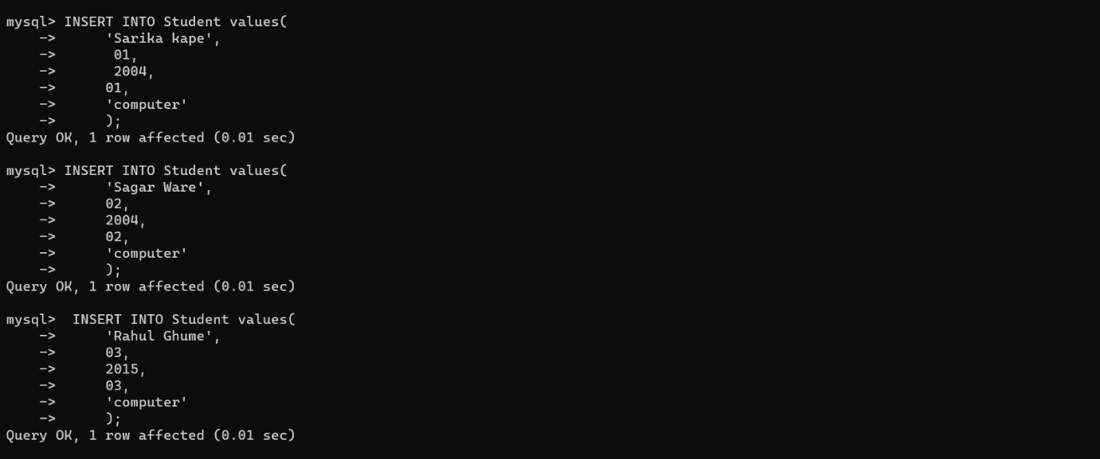INSERT INTO company values('yushh ltd',10,'found',10,'java', 'london');

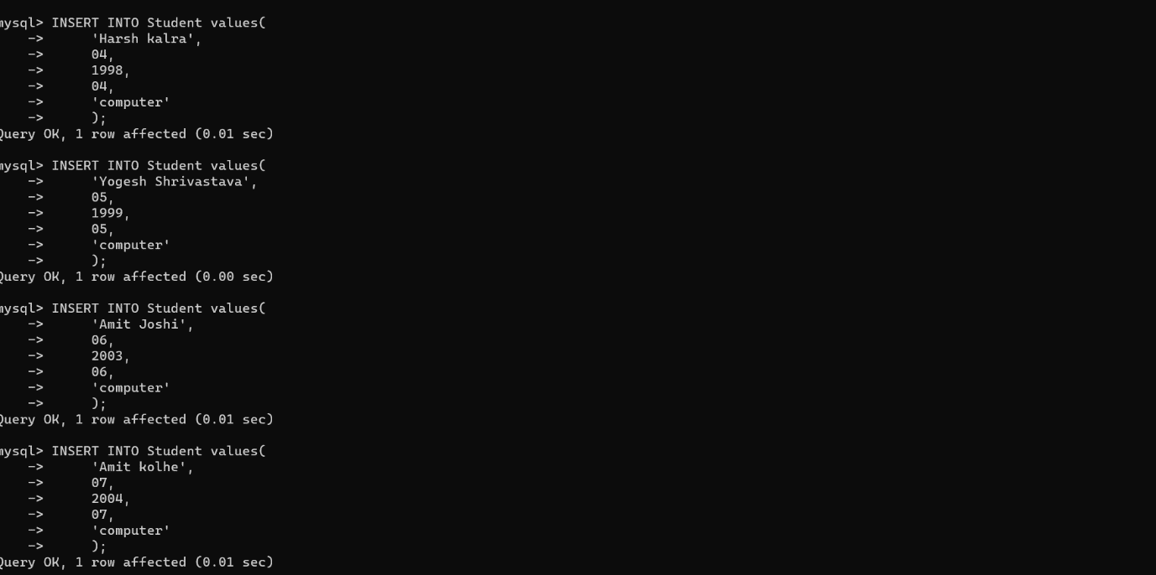

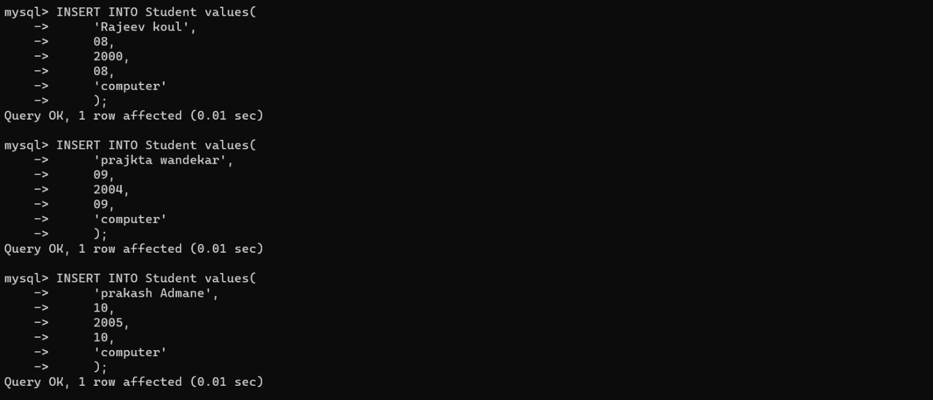

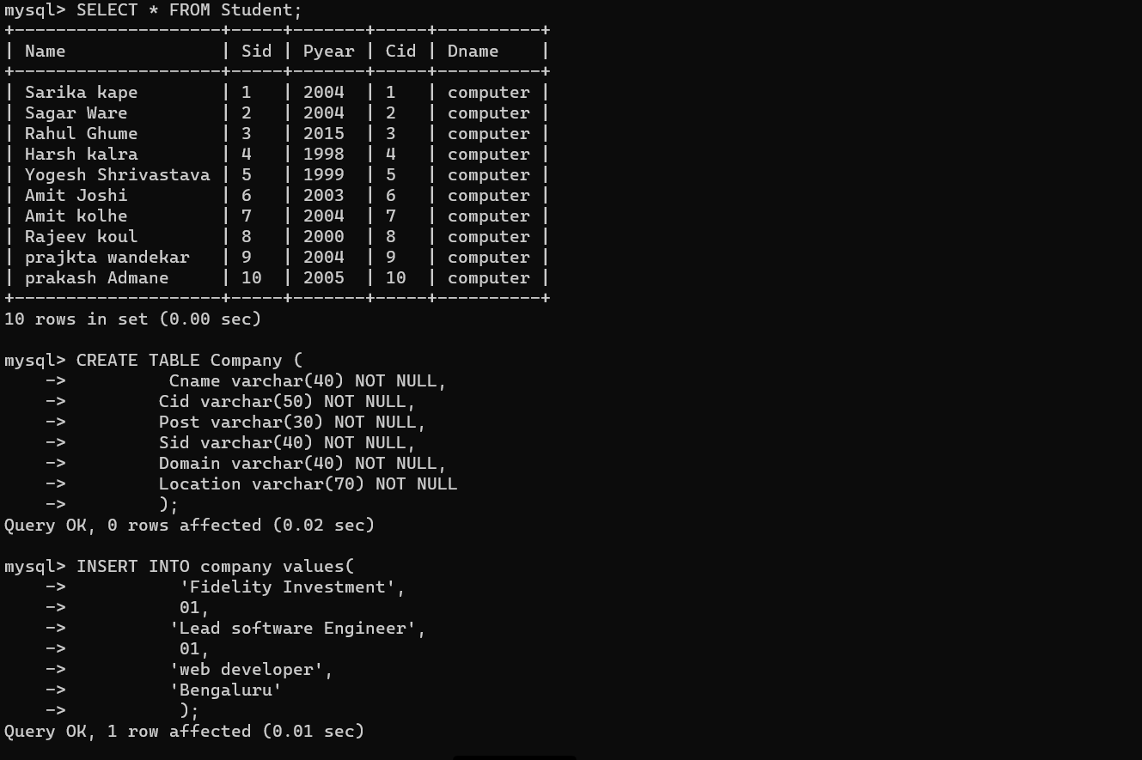

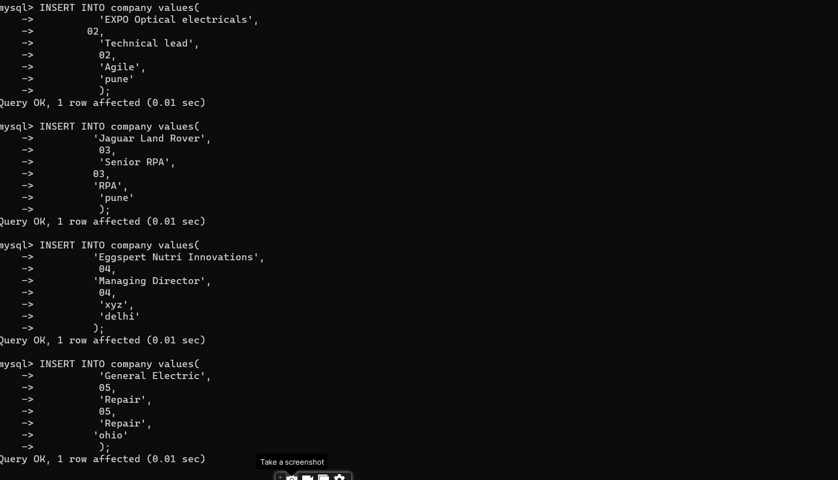

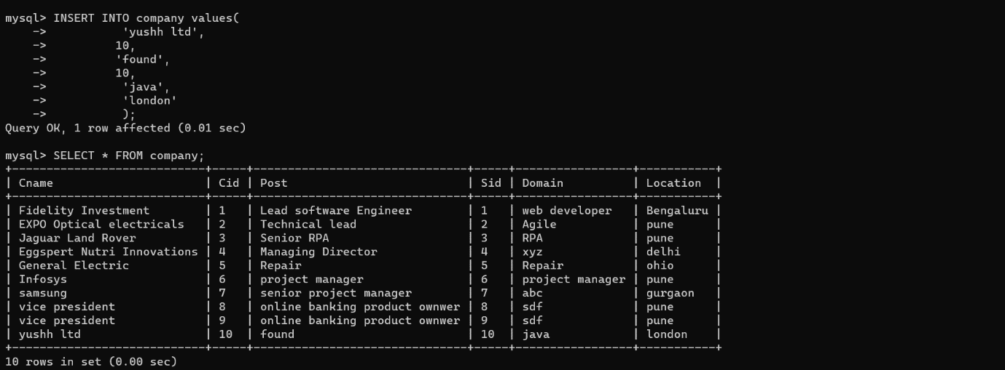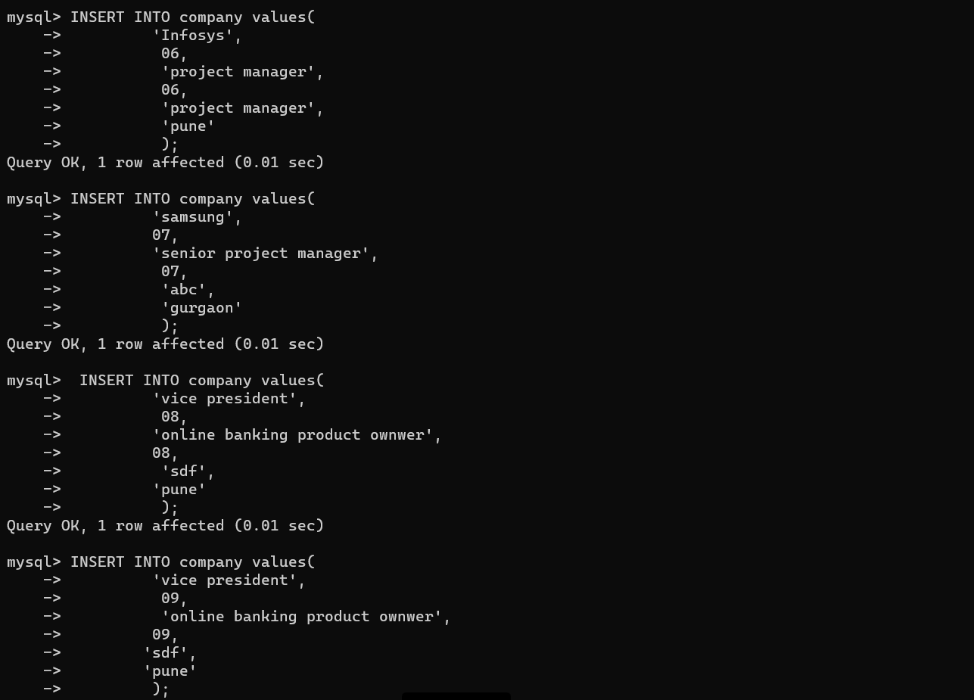

* Alter Command:-

ALTER TABLE alumni MODIFY sid int(30);

ALTER TABLE alumni DROP COLUMN MobileNumber;



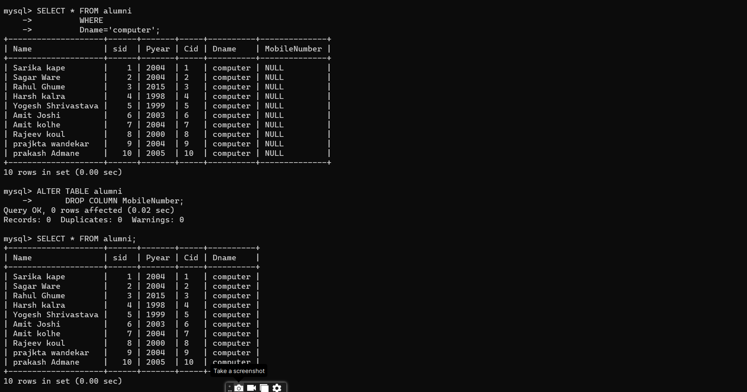

* Update Command:-

UPDATE company SET Cname='SCOE', Post='Managing Trustee',Domain='Management',Location='kopargoan'

WHERE Cid=07;

UPDATE company SET Cname='Technossus',Post='Director program',Domain='Software Engineer',Location='Pune'

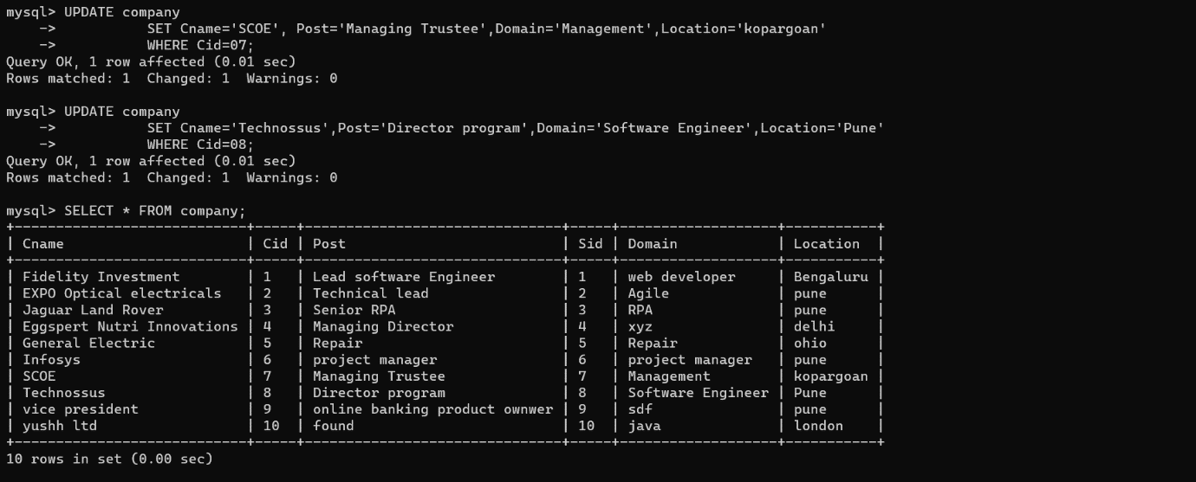WHERE Cid=08;

* DROP command:-

DROP TABLE persons;

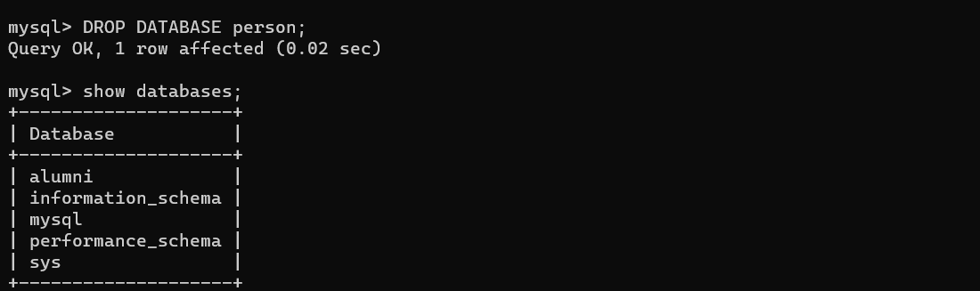

* SELECT Command:-

SELECT * FROM company;

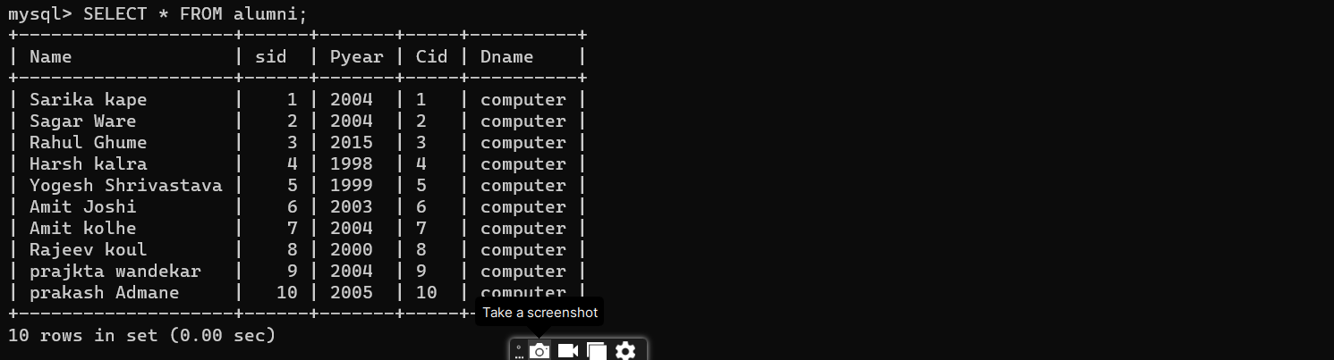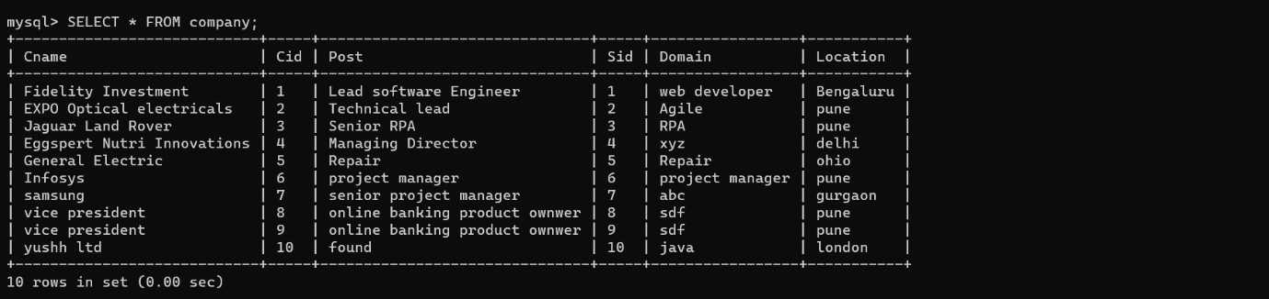SELECT * FROM alumni;

* Operators:-
* ALL

SELECT Name

-> FROM alumni

-> WHERE sid= ALL(SELECT Cname FROM company WHERE location='pune');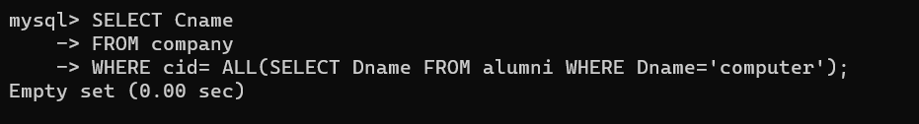

* AND

SELECT * FROM company

-> WHERE location='pune' AND Post='project manager';

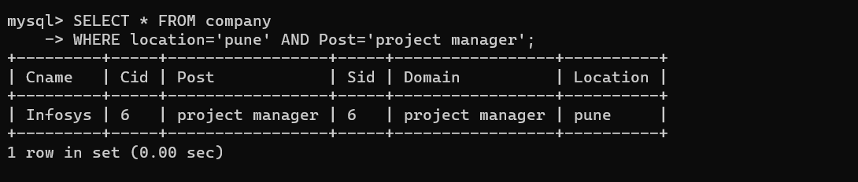

* ANY

SELECT * FROM alumni

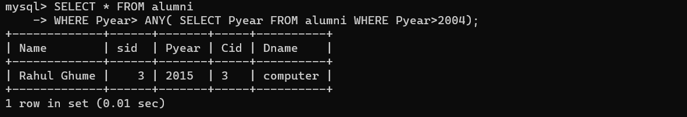 WHERE Pyear> ANY( SELECT Pyear FROM alumni WHERE Pyear>2004);

* BETWEEN

SELECT * FROM alumni

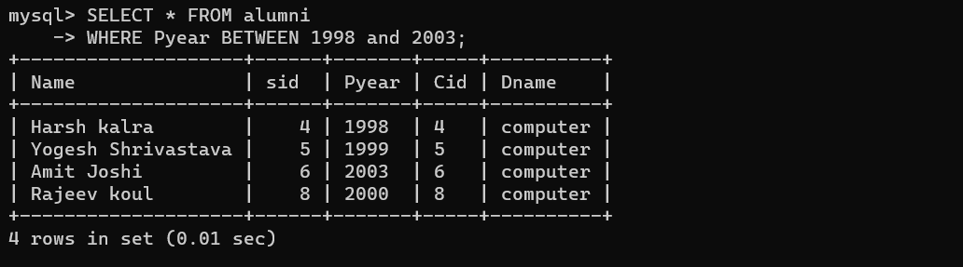 -> WHERE Pyear BETWEEN 1998 and 2003;

* EXISTS

SELECT Name

-> FROM alumni

-> WHERE EXISTS (SELECT Cname FROM company WHERE

company.sid=alumni.sid AND Pyear<2009);

SELECT Name

-> FROM alumni

-> WHERE EXISTS (SELECT Cname FROM company WHERE company.sid=alumni.sid AND Cid<8);

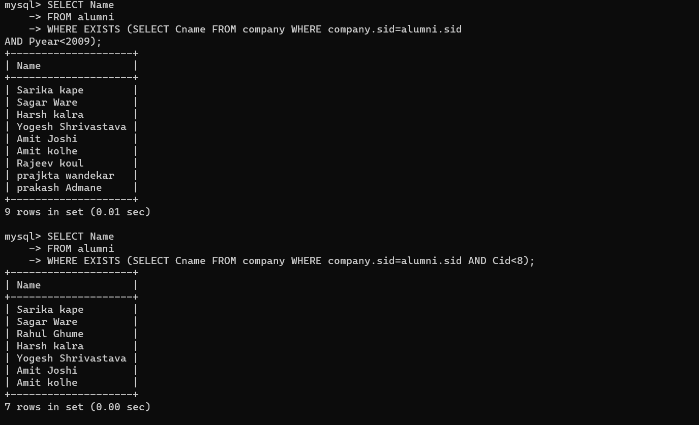

* IN

SELECT * FROM company

-> WHERE location IN('pune','London');

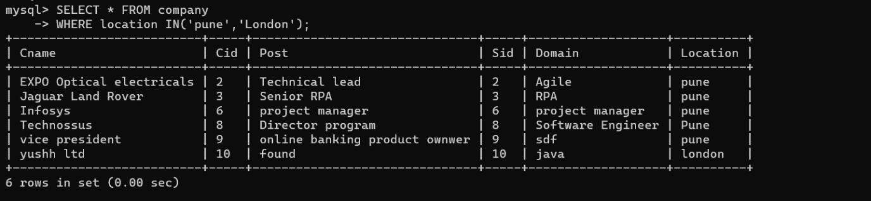

* LIKE AND NOT LIKE

SELECT * FROM alumni

-> WHERE Name LIKE 'a%';

SELECT * FROM alumni

-> WHERE Name NOT LIKE 'a%';

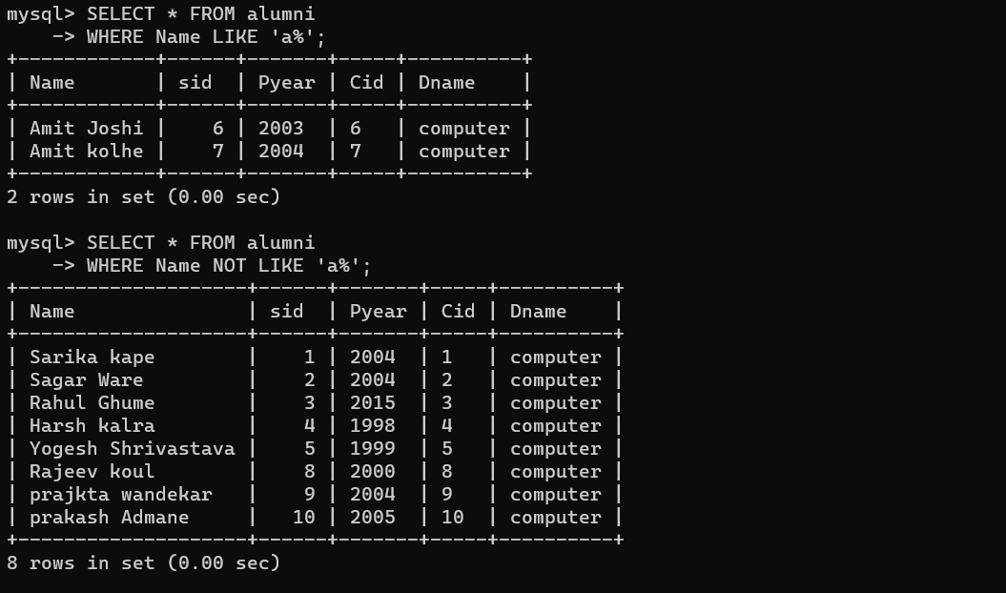

* OR

SELECT * FROM alumni

-> WHERE Pyear =2004 OR Dname='computer';

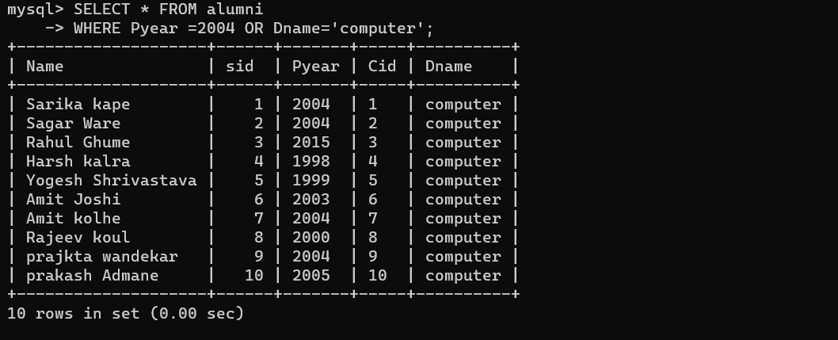

* SOME

SELECT * FROM company

-> WHERE cid > SOME(SELECT cid FROM company WHERE cid<5);

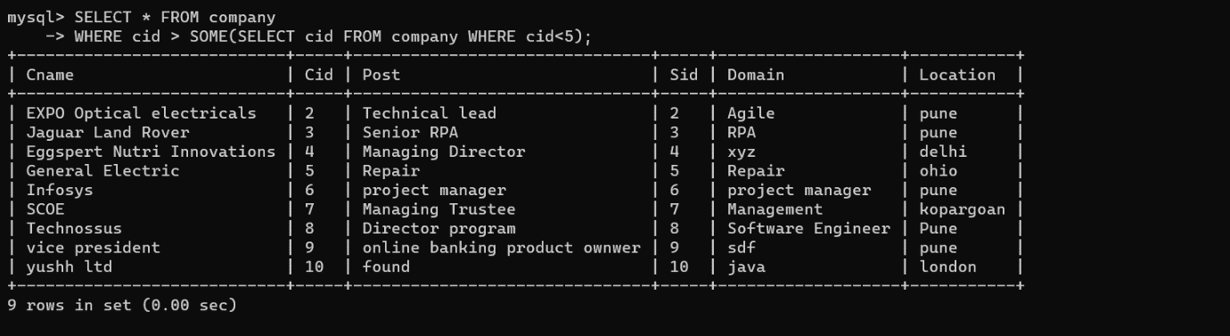

* Functions:-
* COUNT

SELECT Cname ,COUNT(*)

-> FROM company

-> GROUP BY Cname

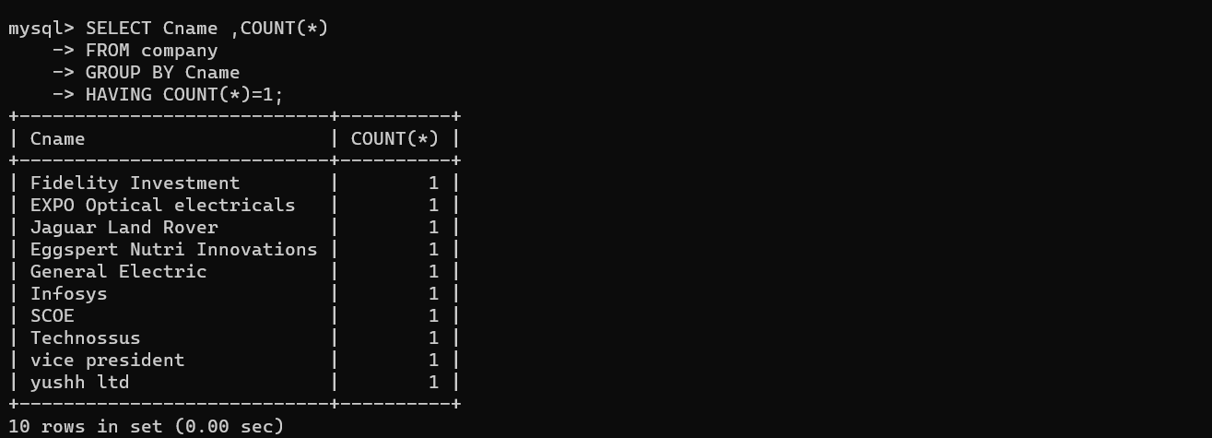 -> HAVING COUNT(*)=1;

* SUM

SELECT Name ,SUM(Pyear)

-> FROM alumni

-> GROUP BY Name

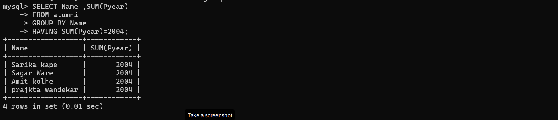 -> HAVING SUM(Pyear)=2004;

* AVG

SELECT AVG(sid)

-> FROM alumni;

* MAX

SELECT MAX(cid)

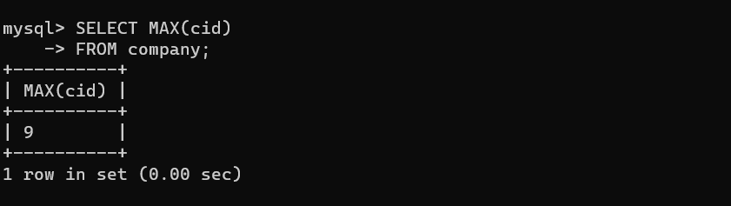 -> FROM company;

* MIN

SELECT MIN(cid)

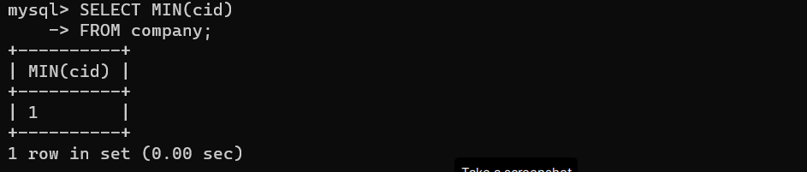 -> FROM company;

* SET OPERATOR
* UNION

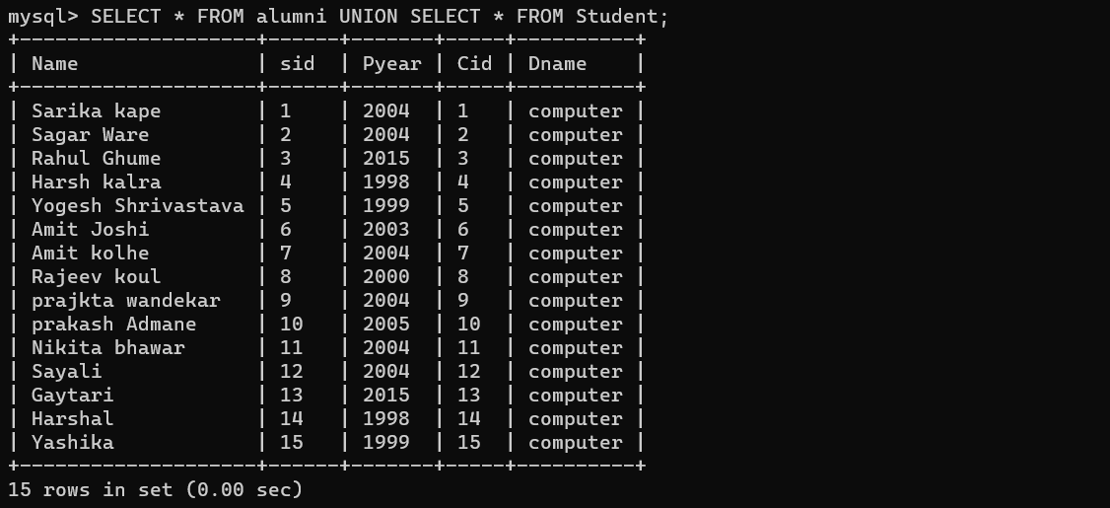SELECT * FROM alumni UNION SELECT * FROM Student;

* UNION ALL

SELECT * FROM alumni UNION ALL SELECT * FROM Student;

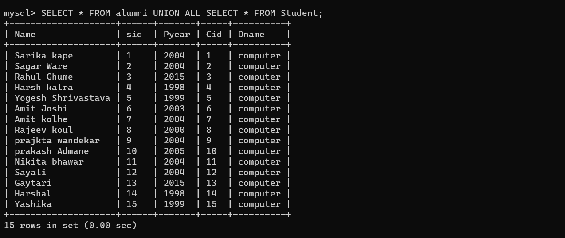

* INTERSECT

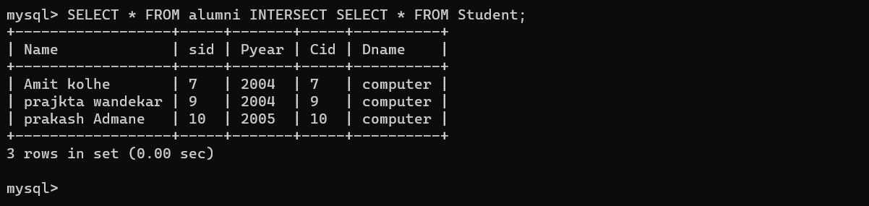SELECT * FROM alumni INTERSECT SELECT * FROM Student;

* VIEW:-
* HORIZONTAL VIEW

CREATE VIEW ALUMNI1

-> AS

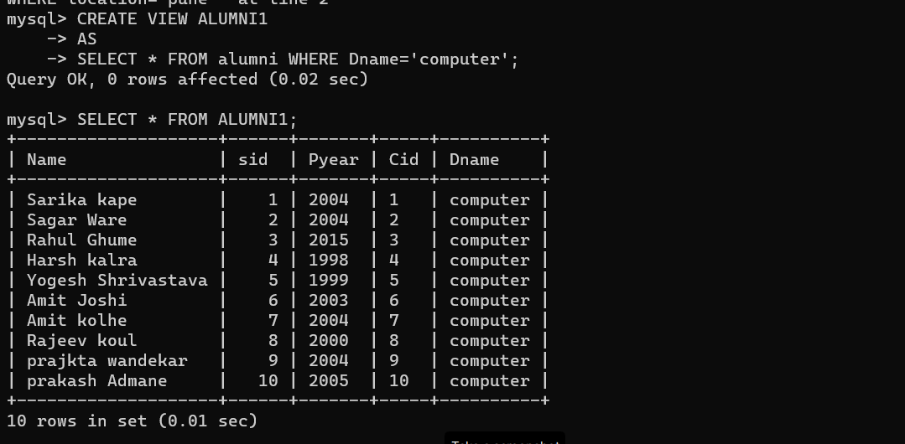 -> SELECT * FROM alumni WHERE Dname='computer';

* HYBRID VIEW

CREATE VIEW ALUMNI2

-> AS

-> SELECT Name,sid FROM alumni

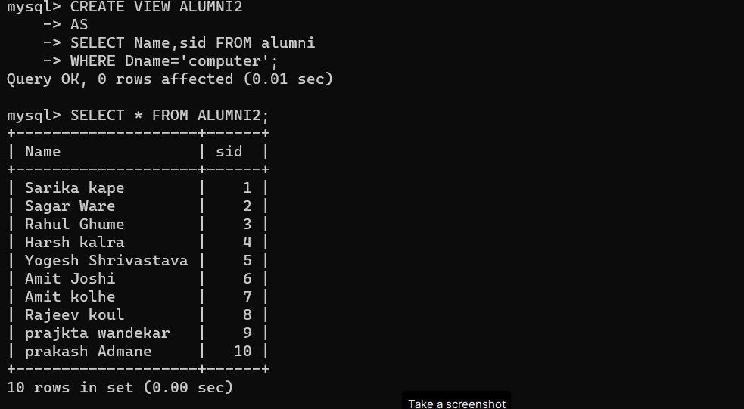 -> WHERE Dname='computer';

* HORIZONTAL VIEW

CREATE VIEW ALUMNI3

-> AS

-> SELECT * FROM company

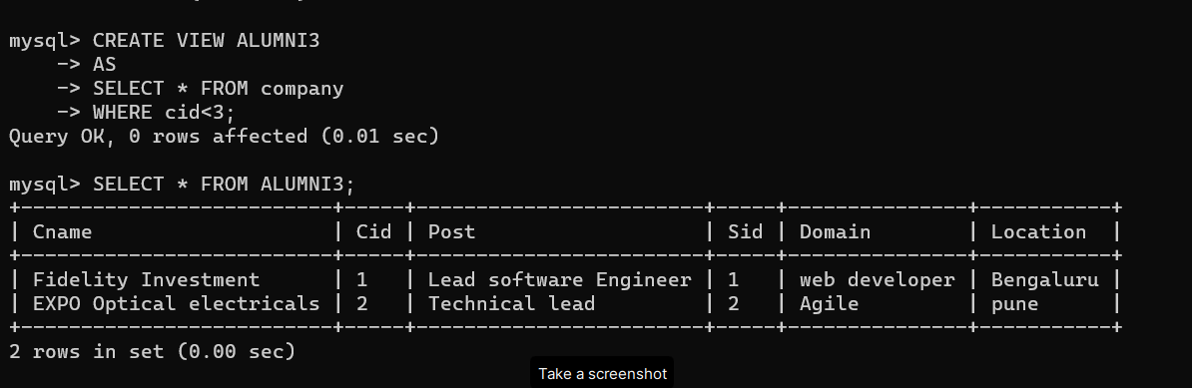 -> WHERE cid<3;

* JOIN
* INNER JOIN

SELECT alumni.sid, company.cname, alumni.Pyear

-> FROM alumni

-> INNER JOIN company ON alumni.cid=company.cid;

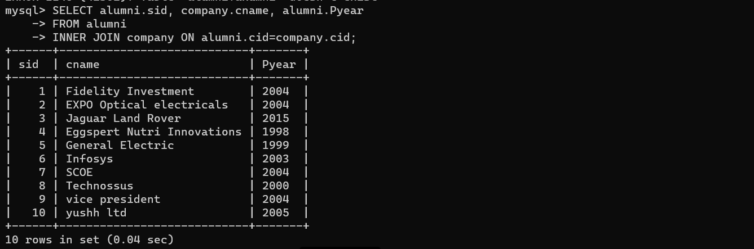

* LEFT JOIN

SELECT alumni.Name, company.Post

-> FROM ALUMNI

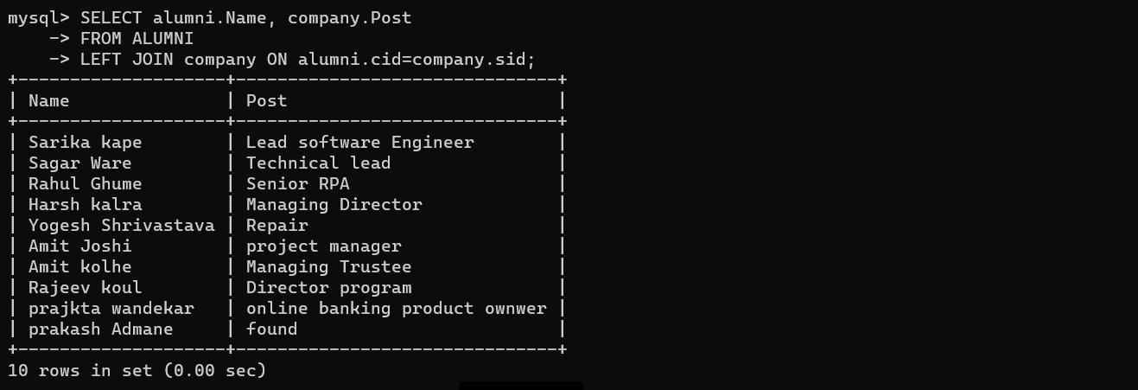 -> LEFT JOIN company ON alumni.cid=company.sid;

* RIGHT JOIN

SELECT alumni.sid, company.cname, alumni.Pyear

-> FROM alumni

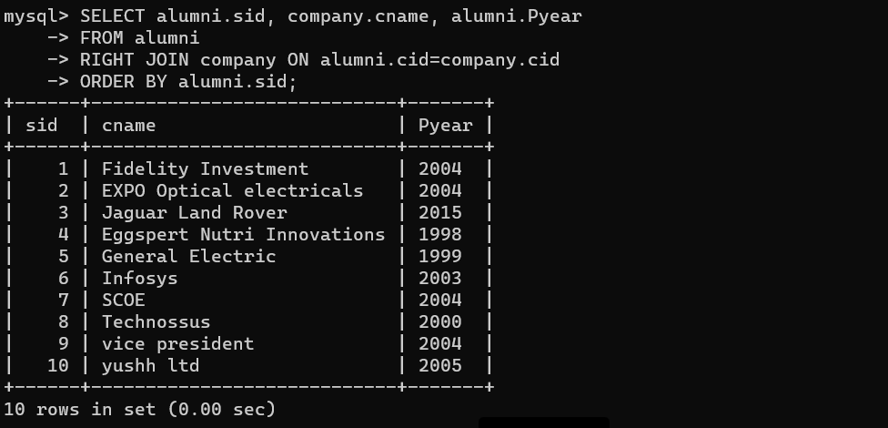-> RIGHT JOIN company ON alumni.cid=company.cid -> ORDER BY alumni.sid;